**POC TITLE**: OJAS-BLOGGER

**TEAM-2:** Swetha Gudla, Mohammed Abraruddin, Uday Bhanu Masani, Sharath Tallapally, Suraj Kumar Mazumdar

**ABSTRACT:**

In this POC OJAS-BLOGGER we have two modules like user and admin, were user have some sub modules like registration, login, adding a blog and editing a blog. Admin module has the sub modules like manage user and deleting user blog,

For this POC we have plan to go through with HTML and JS for front end / user interface (UI), for storing data we have decided to go through with Database, for handling all these we have gone through python and validations are also get handle with python only.

For getting values or putting values in html pages we are going through a python module called EEL module

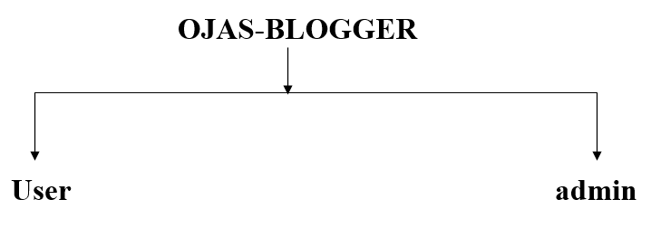

**User**-(registration, login, adding-blog, editing-blog)

**Admin-**(login, manage user, deleting user blog)

**POC-**

1. **Python** (handling all thing from background, handling validation)
2. **HTML and JS** (for User Interface)
3. **DB** (to store the data)
4. **Main modules (pymsql, eel)**

**MODULES**

In this POC we have 2 main modules User and Admin, They consist of some sub modules.

1. Admin Module
2. User Module

Where in our Team we have 5 members we have divided the module admin module has taken by Sharath and Suraj

Were user module has taken by Swetha, Uday and Abrar.

1. **Admin Module**
   1. Admin Login Module (Sharath Talapally)
   2. Admin Users View and Deleting Blog (Suraj Kumar Mazumdar)
2. **User Module**
   1. User Login and Forgot Password (Swetha Gudla)
   2. User Registration and Validation (Uday Bhanu Masani)
   3. Adding, Editing and View Blog, List of Blog (Abraruddin Mohammed)
3. **Admin Login Module**

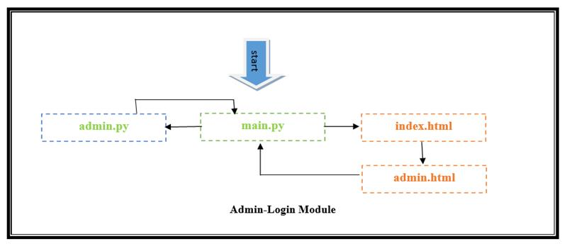

1. **Admin Users View and Deleting Blog**

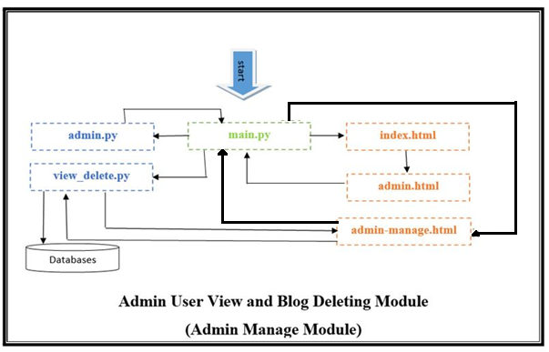

1. **User Login and Forgot Password**

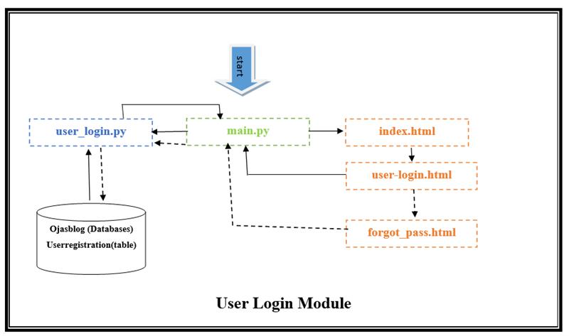

1. **User Registration and Validation**

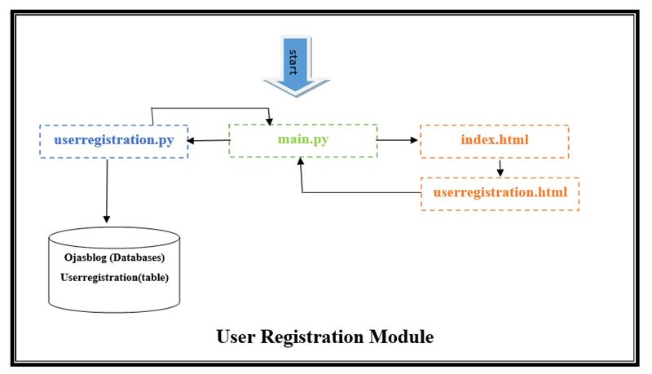

1. **Adding, Editing and View Blog, List of Blog**

